**Solve with us - Consolidated Guidelines**

**What is "Solve with Us"?**

“Solve with us” is a feature that would help students solve questions on Embibe’s platform step by step. This feature helps us to track student’s learning and give them feedback, as we can track where and at which step students have to improve.

When the student selects the solve with us feature on our platform, then for all objective type (FIB, MCQ, TF, Drop Down) questions and Subjective Answer type questions, the system will ask the user to answer the main question first. However they can go into the solve with us part not answering the main question by clicking on the **Solve With Us** button appearing at the bottom of the screen.

How to create a solution incorporating solve with us in CG.

1. In this process, we will break the solution into steps.
2. We will identify the word/term/number/symbol which forms the key-word/term/number/symbol for that particular step.

a. Try to select word/term/number/symbol which can be easily typed even from a keyboard available in mobile.

b. Try to avoid selecting multiple words which may increase chances of mistyping them exactly by the user.

c. Try not to select more than two key-words/terms/number per step. If the step is very lengthy and important try to select two key-word/term/number/symbol and create FIB.

d. Selected word/term/number cannot be a very obvious thing to answer, without applying the concept  required to answer it.

*Example:*

Question: Arrange the red, yellow, blue colour lights in the increasing order of their frequency.

Solution: Frequency of red light < Frequency of yellow light < Frequency of blue light.

Here if we highlight only one colour (say blue), from the given list in the question it is very obvious to guess the correct answer, not applying the subject knowledge.

e. Expression like https://www.google.com/chart?cht=tx&chf=bg,s,FFFFFF00&chco=000000&chl=x%2B3 or https://www.google.com/chart?cht=tx&chf=bg,s,FFFFFF00&chco=000000&chl=%7B1%2B2x%2B%5C+x%7D%5E%7B2%7D are allowed.

3. “Solve with us” is mandatory for every question and for every step.

4.**Solve with Us**for a diagram-based question which seeks the labelling of a diagram, one of the labels should be created as blank and the user should be able to find out the label or make use of a relevant hint.

**5.**The *hint* for SWU should be relevant to the highlighted key-term.

6. If the solve with us blank has multiple possibilities then after highlighting the word and creating the FIB, we click on the https://lh3.googleusercontent.com/0xOWCtB4JEHkknXCpPnD5dQgAKK6tcvpLXSkf4pMW7QhG6WmIBvhVc588vWeQyaV-W_SbXpKimtiZ403kAWR4BIu6MbPMMV_-LJJ0nnUbeRwcGFMskBy7iwCqhsSWTBTB2xHeXBC icon and enter the other possibilities.

**UAT Guidelines on Solve with Us**

Fatal errors must be avoided/corrected else the content would be rejected. Dissatisfiers should also be avoided.

|  |  |
| --- | --- |
| **Type of Issue/Error Found** | **Category** |
| [SWU content is not same as the step](https://www.google.com/url?q=https://new-content-admin.embibe.com/questions/5ee352a5456475c9ed5ad318)&sa=D&ust=1602660031436000&usg=AOvVaw2DxuWtJT3TC7m1cuaqBVJU) | Fatal |
| The FIB chosen for SWU is very straightforward and it doesn't evaluate the student's understanding of the underlying concept/competency | Fatal |
| SWU is not created for all the steps of the question (Except GK) | Fatal |
| Special symbols that are not present in the onscreen keyboard are present in the FIB | Fatal |
| SWU hint contains the answer of SWU FIB | Fatal |
| SWU hint is same as overall question level hint | Dissatisfier |
| SWU hint is not leading to the correct answer | Fatal |

**Do’s and Don’ts in Solve With US (SWU):**

1. Don’t highlight the final answer.
2. Don’t highlight the formulas in Quant/Reasoning.
3. Don't give irrelevant hints in SWU. It should be related to the question only.
4. Don’t highlight 2-3 lines or half of the solution in the solve with us, try to hide one word/number.
5. Don’t write hints like, ‘refer to the previous step to get the value of this step’ etc. If at all you want to refer to the  previous step then, you can write it as ‘arrange the variable one side or take 20 to the other side and subtract’ etc.
6. Don’t create steps in Solve with us and hints.
7. Use math type only if it is required in the Solve With Us hint.
8. If you edit the solution, Solve with us content will not get updated automatically. Please manually update it and click on create or update FIB to save the changes you made in SWU. Make sureSolve With Us content should be the same as the step content.

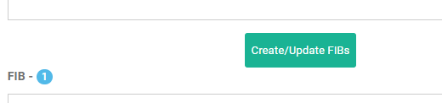

1. The SWU should never be ambiguous.
2. Hidden part of the solution(FIB) should not be mentioned in the solve With US hints.
3. When you are highlighting any word/letter/number make sure that extra space, comma, full stop are not included.

**Solve With Us examples:**

**Quantitative Aptitude:**

**Example 1:**

The sum of five numbers is 290. The average of the first two numbers is 48.5 and the average of last two numbers is 53.5. What is the third number?

**Appropriate Solve With Us:**

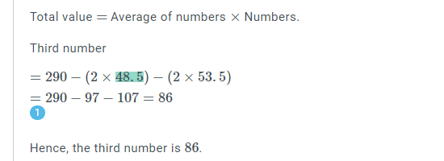

The highlighted number here is the average of the first two numbers.  It will help the students to understand the calculation.

**Inappropriate Solve With Us:**

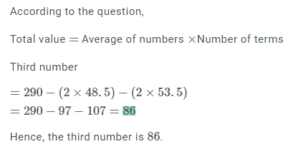

The highlighted word here is the final answer. So it is an inappropriate SWU.

**Example 2:**

The marked price of an article is Rs.275. A shopkeeper allows a discount of 5% and he gets a profit of 4.5%. The actual cost of the article is_____.

**Appropriate Solve With Us:**

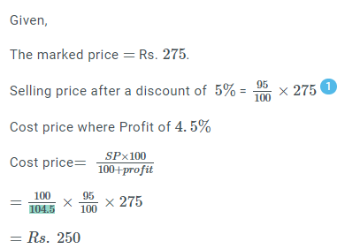

The highlighted number here is the part of the calculation. It will help the student to understand the calculations and substitution part.

**Inappropriate Solve With Us:**

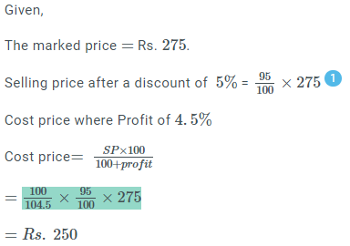

Here an entire equation is highlighted which is not correct. It is very difficult for the students to write the exact equation and also it is difficult to give Solve With Us hints for this.

**Example 3:**

A thief manages to escape the Tihar Jail. He is running at a speed of 30 km/h. A policeman comes to know about this escape two hours later. He immediately starts running after the thief at a speed of 36 km/h. After how many hours will the policeman be able to catch the thief?

**Inappropriate Solve With Us:**

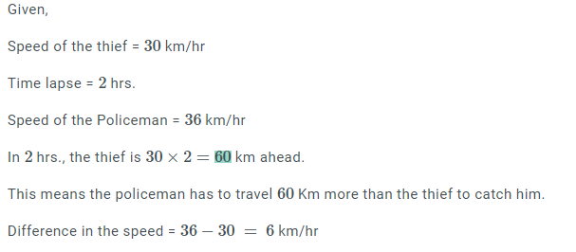

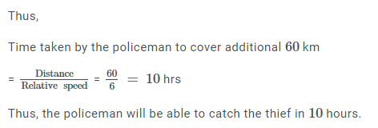

Here the highlighted number is the product of 30 and 2 and it is too easy.

**Appropriate Solve With Us:**

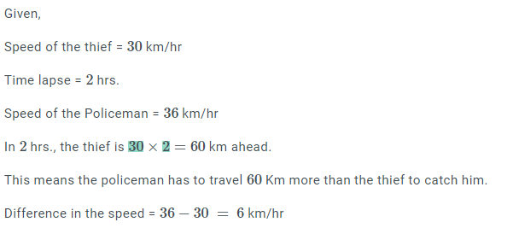



Instead of highlighting 60, we can create two FIBs here. And hints for these should be relevant to the question. For example here for ‘2’ you cannot give a hint like ‘the first prime number’.  ‘2’ is the time lapse according to the question.

**Reasoning:**

**Example 1:**

If SEASONAL is written as ESSANOLA, how can SEPARATE be written in that code?

**Inappropriate Solve With Us:**

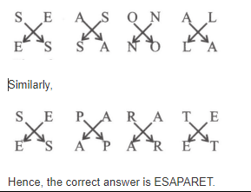

Here only the image is there.  Even though the image is self explanatory, we will not be able to edit the image and will not be able to create SWU.

**Appropriate Solve With US:**

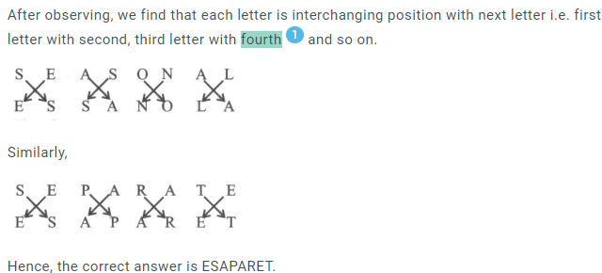

Here, the logic is explained and now we will be able to create the SWU.

**Example 2:**

The question given below consists of a statement, followed by two arguments numbered I and II. You have to decide which of the arguments is a 'strong' argument and which is a 'weak' argument.

Statement: Should the political parties be banned?

Argument:

I. Yes, it is necessary to teach a lesson to the politicians.

II. No, it will lead to an end of democracy.

**Inappropriate Solve With US:**

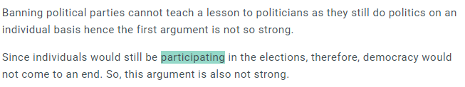

**Or**

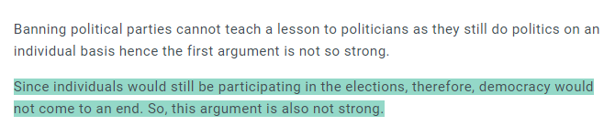

Here highlighting the word ‘participating’ will create ambiguity. There is a chance that students will write synonyms of the hidden word. In the second case, the entire line is highlighted which is inappropriate.

**Appropriate Solve With US:**

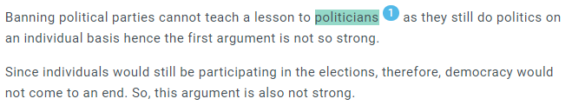

Here  the word ‘politicians’ is highlighted. There won’t be any ambiguity here when a student is entering the word.

**Example 3:**

**Appropriate Solve With Us:**

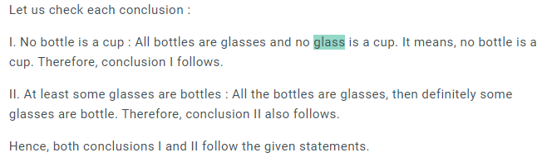

**Inappropriate Solve With US:**

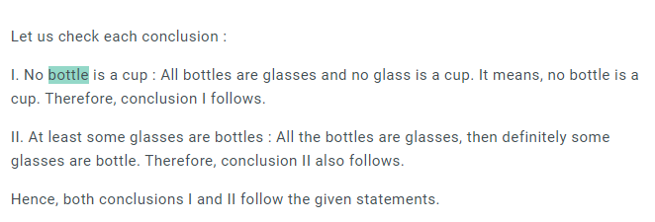

Here the hidden word is the part of the question (conclusions). Hiding part of the question is inappropriate.

**Guideline Document for Learning Map**

**What is a Learning Map(LM)?**

A learning map (LM) for a given examination/syllabus is the hierarchical skeleton of the course as visible to teachers and students. It is an integral part of Embibe’s pedagogy besides the Knowledge Graph. While KG is an internal knowledge representation of concepts and competencies whereas LMs are marketing facing views of Embibe’s knowledge. Single Embibe KG will serve multiple LMs.

* The present sequence of attributes in the learning map is:
* Namespace >> Goal >> Exam >> Grade >> Subject >> Unit >> Chapter >> Topic
* All content on Embibe will be compulsorily tagged to a  learning map
* Each topic in the learning map is connected  to  necessary concepts (as per the syllabus) in the knowledge Graph, hence the entire curriculum can be built using Embibe KG
* LM is designed after a thorough study of exam syllabus, reference books, and previous year papers
* The tagging of content at various levels like Unit, chapter, and topics allows  Embibe consumer app to package the content at any level based on the needs of the students.
* Also, each question in the Question Bank may be  tagged with the multiple learning maps, hence we can generate a practice and test packs for different exams with appropriate questions

**What are Embibe Pre PG Learning Maps?**

Pre PG segment at Embibe deals with competitive examinations taken by candidates for entry into jobs after graduation. These include Banking exams, SSC exams, Railways exams, Insurance exams, UPSC exams, UGC NET etc. Embibe prepares learning maps for each of these exams based on the syllabus prescribed by the authorities conducting the exams. LMs represent Embibe’s academic viewpoint on the syllabus structure prescribed for the exams. Below given are the key points on Embibe Pre PG LMs:

* Each competitive exam will have its own Embibe LM. An example of LM structure for IBPS PO exam is given below:
* Namespace: Embibe
* Goal: Banking
* Exam: IBPS PO
* Grade: NIL
* Subject: Reasoning
* Unit: Analytical Reasoning
* Chapter: Syllogism
* Topic: Approaches to Solve Syllogism
* All the content and questions pertaining to Pre PG books would be tagged to an exam LM in addition to Book’s TOC. Each question in the book may be tagged to multiple LMs, depending on the relevance and context of a question.
* There might be overlapping topics across various competitive exams. However, each exam would have a separate LM.
* As per the syllabus, each topic in the LM would be connected to necessary concepts in the Embibe’s Knowledge Graph. Embibe’s KG would provide a list of concepts necessary to learn a particular topic, simultaneously analysing the skills and competencies required to master the topic.

A partial graph of KG “Syllogism”  is given below:

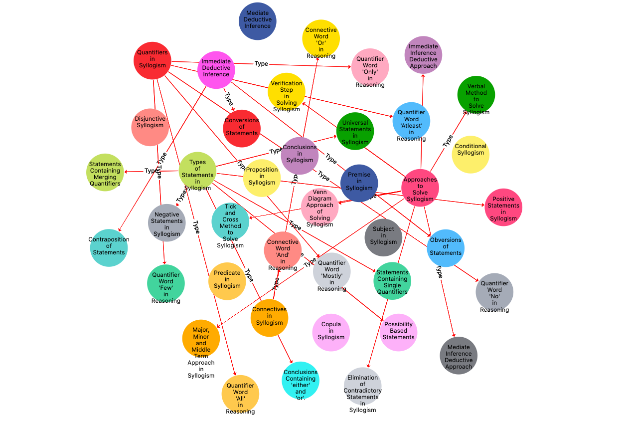

**What is TOC?**

TOC is a table of content of each book, representing the content of books in the same order as given in the book. Typically a chapter name would be Level-1 in TOC. Heading-1 would be Level-2 in TOC. Embibe TOCs have 6 flexible levels. Labeling these levels will vary from book to book. The chapter and topics are likely to be part of each TOC.

The TOC should not get confused with LM. While LM is the Embibe knowledge structure for a given board, TOC is an exact replica of the knowledge structure of any given book